
115 Saxony Drive  Pittsburgh, PA 15241 |  | p. 412-680-3222  f. 412-245-1515 |  | Kelly@FieldOfPlayMarketing.com  http://pittsburgh.wiseworks.org/

WISE Pittsburgh
  - Benefits of WISE Membership

Table of Contents
- Executive Summary
Who We Are
Mission Statement
Our Chapters
- Benefits
- Mentoring
- Networking
V. Professional Development

Executive Summary
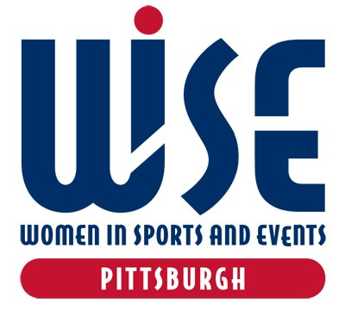 | Who We Are WISE (Women in Sports and Events) is the leading voice and resource for professional women in the business of sports. Through ongoing meetings, special events and mentoring programs, WISE offers its members the opportunity to gain valuable insights and connections that can provide them a competitive advantage in their current position and as they advance in their careers.  Our Mission The WISE (Women in Sports and Events) mission is to create and support programs that enhance the success and growth of women in the business of sports. The organization strives to be the definitive source for businesswomen seeking information about issues, challenges and opportunities impacting all stages of their career — from entry level to senior management and those in transition.  Our Chapters Founded in 1993, WISE is a national membership organization and registered 501(c)3 public charity headquartered in New York City, with chapters in Atlanta, Boston, Chicago, Cleveland, Houston, Los Angeles, NYC Metro, Pittsburgh, San Diego, San Francisco/Bay Area, South Florida and Washington D.C. WISE National, governed by the National Board of Directors, leads the overarching strategy and provides resources accessible to all members, while each WISE chapter elects its own board to carry out WISE’s mission at the local level. Chapters provide programming and valuable networking opportunities in their region and work with the National Board to deliver WISE initiatives such as the WISE Within Mentor Program and Speed Mentoring Roundtables. - See more at: http://wiseworks.org/about/about/#sthash.BYcwL6wJ.dpuf

Benefits
Put WISE to work for you!  Take advantage of the professional development, career and networking resources that WISE offers.  Member Benefits |   Student | 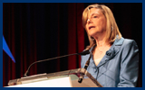  Professional | 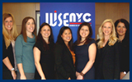  Corporate
Networking opportunities with accomplished WISE women in the industry | ✔ | ✔ | ✔
Access to exclusive events discussing industry and career-related topics | ✔ | ✔ | ✔
Discounted or free admission to WISE chapter events, such as our annual Speed Mentoring Roundtables | ✔ | ✔ | ✔
Discounted rate to WISE national events, such as the annual WISE/R Symposium and WISE Awards Luncheon in NYC | ✔ | ✔ | ✔
Members-only access to our online Membership Directory | ✔ | ✔ | ✔
Members-only access to CareerWISE, our career resource center, featuring exclusive WISE content | ✔ | ✔ | ✔
TeamWork Online "MVP Access/College" program (Free access to career resources and content; a $60 value) | ✔ | ✔ | ✔
TeamWork Online's weekly job summary | ✔ | ✔ | ✔
WISE Rewards — special discount offers such as SBJ subscription and discounts to non-WISE industry events | ✔ | ✔ | ✔
Volunteer and WISE committee service opportunities at both the national and chapter levels | ✔ | ✔ | ✔
WISE Women of the Year nominations and voting |  | ✔ | ✔
Leadership opportunities at both the national and chapter levels |  | ✔ | ✔
Participation in our prestigious WISE Within Mentor Program (application required) |  | ✔ | ✔
Participation in our WISE Executive Leadership Institute (application required) |  | ✔ | ✔
Board eligible at both the national and chapter levels |  | ✔ | ✔
 | Student | Professional | Corporate
 | $40  Verification required.* | $100 | Discounts start with a minimum of five members

Mentoring
- Mentoring event with Point Park University
- Speed mentoring event with Executive and Middle Management supporting entry level
- Reverse Speed Mentoring Technology
- Bi-monthly Executive breakfast mentoring meetings

Networking
- Events that support our local teams – Pirates, Pittsburgh Passion, Riverhounds, Wild Things, Steelers
- Women of the Year Event

Professional Development
Suggested sessions:
- Project Management Best Practices
- 3 Things I Need To Do To Stand Out In My Organization
- Representing Well – Does Social Media Really Affect Me At Work?
- Millennial Professionals – My Contribution Matters
- Listening and Communication Skills
- Reverse Mentoring Technology Session
- How To Manage Male Counterparts
- Picking the Right Wine (Susan Citron)
- Broadcasting On the Sidelines – Beat Writer Round Table
- Webinars – Managing Multiple Generations, Hiring Smart, etc.

Description of Business

WISE Gold Sponsorship ($2,500)
- Company representative opportunity to speak at each program
- Opportunity to host a program at your facility/office
- Board position
- 10 memberships
- 4 tickets to “Woman of the Year” event
- Logo placement on invitations to each program and “Women in Sports” event
- Opportunity for company banner at “Women in Sports” event

Promotion

As a sponsor you will receive the following benefits:
- Logo on evite for each program and event
- Print and possibly radio and TV advertising (as secured)
- Logo on WISE website
- Social media – (3 posts per event) Facebook, Twitter

